SWE 573 Software Development Practice, Fall 2012
Instructor: M. Ufuk Caglayan

Project 1
RWPA: Reader-Writer Process Application
Requirements Specifications Document

08.10.2012
Revision 1.0

By: Mustafa Göksu GÜRKAŞ
Student Id: 2011719225

Revision History

Revision | Date | Explanation
1.0 | 08.10.2012 | Initial requirements

Table of Contents

Revision History 2
Table of Contents 3
1. Introduction 4
2. Requirements 4
2.1. Requirement 1. Main User Interface and Functions 4
2.2. Requirement 2. Function 1: Load Configuration File 4
2.2.1 Use Case Name: Load Configuration File 4
2.3. Requirement 3. Function 2: Start the simulation 5
2.3.1 Use Case Name: Start the simulation 5
2.6. Requirement 6. Development Environment 6
2.7. Requirement 7. Security 6
2.8. Requirement 8. Reconfigurability 6
2.9. Requirement 9. Logging 6
3. Testing 6

1. Introduction

The purpose of this software project is to design and develop an application on Linux, Windows or MacOS platform by using a procedural/object oriented programming language such as C, C++ or C#, to accomplish the following main tasks.
- The user should be able to execute a program that shall be able to create a defined number of reader and writer processes,
- Those child processes shall be able to simulate reading/writing actions from/to a shared variable by random delays,
- The actions taken by the processes shall be traceable through a log file.

Functional details of the application are given in the following sections of this document.

2. Requirements

2.1. Requirement 1. Main User Interface and Functions

Main User Interface (Main Menu) and Functions are as follows:

Reader-Writer Process Application Operations
- I want to load configuration file
- I want to start the simulation of reader/writer processes

All functions above are action buttons on an application frame.

2.2. Requirement 2. Function 1: Load Configuration File

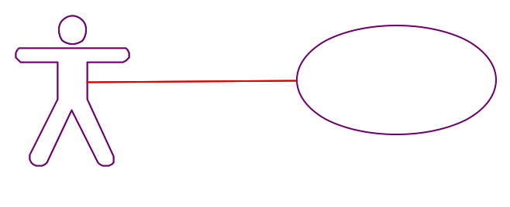

2.2.1 Use Case Name: Load Configuration File
Actors:
- User (Uses the application to simulate the behavior of reader/writer processes)
Triggers:
The user indicates that she has finished defining the parameters to be used in the program and wants to load them.
Pre-conditions:
The user has edited, saved and closed the configuration file as needed. For the name and the format of the file, refer to Requirement 6, Reconfigurability.
Post-conditions:
The configuration file will be loaded to the application and the simulation will become ready to start.
Normal Flow:
- The user indicates that she wants to load the configuration file to make the application ready to run.
- The system will provide the user to browse through her file system to select the file she needs.
- The user will select the configuration file to load.
- The system will load the content of the configuration file.
- The system will inform the user that the configuration file is loaded and the application is ready to simulate.
Alternate Flows:
4A1. The system will discover that the name of the selected file is incorrect, and will inform the user.
- The system will indicate that the name of the configuration file is not correct.
- The system will inform the user to check the name of the file to be loaded.
- The use case returns to step 2 and continues.
4A2. The system will discover that the configuration file couldn’t be read from the file system, and will inform the user.
- The system will indicate that the configuration file is not readable.
- The system will inform the user to check the configuration file’s availability to be read.
- The use case returns to step 2 and continues.
4A3. The system will discover that the configuration file is misformatted and paramters couldn’t be retrieved, and will inform the user.
- The system will indicate that the contents of the configuration file is not well-formatted.
- The system will inform the user to check the format of the configuration file.
- The use case returns to step 2 and continues.

2.3. Requirement 3. Function 2: Start the simulation

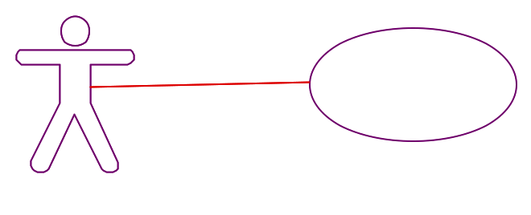

2.3.1 Use Case Name: Start the simulation
Actors:
- User (Uses the application to simulate the behavior of reader/writer processes)
Triggers:
The user indicates that she has finished loading of configuration file and wants to start the simulation process.
Pre-conditions:
The configuration file has been loaded successfully.
Post-conditions:
Main program will start to create a defined number of reader and writer processes.
Normal Flow:
- The user indicates that she wants to start the main program to create child processes.
- The system will create the reader processes.
[Parallel Flow]
  - The reader process will suspend for a random delay between 0-n msecs, where “n” is taken from the configuration file as a parameter. The suspension time will be logged.
  - At the end of suspension, the reader process will log its resuming time to log file.
  - The reader process will lock the shared variable to avoid writers to write on it and log this operation.
  - The reader process will read the value of a shared variable and log the value of it.
  - The reader process will remove the lock and log this operation.
  - The use case returns to step 2.1 and continues.
- The system will create the writer processes and log this action to a log file.
[Parallel Flow]
  - The writer process will suspend for a random delay between 0-m msecs, where “m” is taken from the configuration file as a parameter. The suspension time will be logged.
  - At the end of suspension, the writer process will log its resuming time to log file.
  - The writer process will lock the shared variable to avoid readers to read from it and log this operation.
  - The writer process write a value to a shared variable and log the value of it.
  - The writer process will remove the lock ang log this operation.
  - The use case returns to step 3.1 and continues.
- The system will inform the user about the number & type of the created processes, their maximum delay time and the name/location of the log file to be created during the runtime.
Alternate Flows:
2.3A1. The reader process will discover that a writer process will be writing to the shared variable.
- The reader process will indicate that a writer process occupies the shared variable.
- The reader process will start to wait for writer process and log this operaiton.
- The writer process will signal the waiting processes about completion of its operation.
- The use case returns to step 2.3 and continues.
3.3A1. The writer process will discover that a reader process will be reading from the shared variable.
- The writer process will indicate that a reader process occupies the shared variable.
- The writer process will start to wait for reader process.
- The reader process will signal the waiting processes about completion of its operation.
- The use case returns to step 3.3 and continues.

2.4. Requirement 4. Development Environment

The software will be developed in either a procedural programming language such as C or in an object oriented programming language such as C++ or C#. The development and operation environment shall be Linux, Windows or MacOS.

2.5. Requirement 5. Security

None.

2.6. Requirement 6. Reconfigurability

The Reader-Writer Process Application must be reconfigurable through a configuration file in the sense that the number of child processes to read/write from/to a shared variable could be changed as the user needs. On the other hand, the application shall be reconfigurable as the delay intervals of the reader/writer child processes could be updateable through the configuration file.

The name of the file to be loaded must be config.rwpa and the content of the file must be as follows:

reader <number of reader processes>
writer <number of writer processes>
n <max delay time (msecs) for reader processes>
m <max delay time (msecs) for writer processes>

2.7. Requirement 7. Logging

Each significant action of main program such as the startup of the program, the creation of a child process and the end up of the application shall be logged to a shared log file. In the same way, the events that occur in the child processes such as starting/ending of a child process and reading/writing/suspending/resuming actions of a child process shall be logged to the shared log file.

The name of the log file shall be log.rwpa and the format of a log record shall be as follows:

yyyymmdd hh/mm/ss/sss, pid=<process id>, <log message in plain text>

3. Testing

The test document must cover the details of testing the correct operation and boundary conditions of each requirement given in Section 2. The details of the testing document will be produced during the design. No acceptance test is specified as part of the requirements specification.

